

# include<iostream>

using namespace std;

int max(int a[5]);

int min(int a[5]);

int main()

{

int x[5];

for (int i = 0; i < 5; i++)

{

cout << "Please Input One Number!"<<endl;

cin >> x[i];

}

cout << "the Inout is:" << endl;

for (int i = 0; i < 5; i++)

{

cout << x[i] << endl;

}

cout << "the min is " << min(x)<< endl;

cout << "the max is " << max(x) <<endl;

return 0;

}

int max(int a[5])

{

int j;

int max1 = a[0];

for ( j = 0; j < 5; j++)

{

if (max1 > a[j])

{

max1 = a[j];

}

}

return max1;

}

int min(int a[5])

{

int i;

int min1 = a[0];

for (i = 0; i < 5; i++)

{

if (min1 < a[i])

{

min1 = a[i];

}

}

return min1;

}

结果显示：

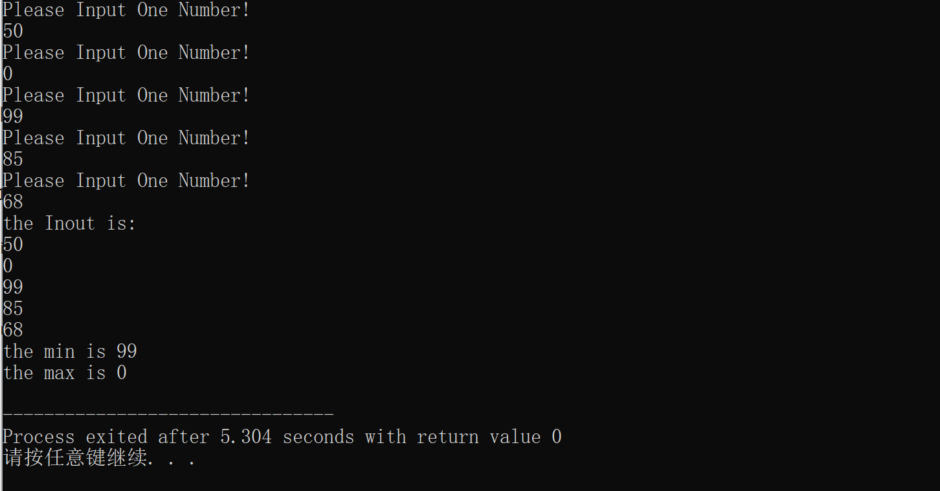

感想：1、c++知识与c语言有比较大的关联，比如这里for循环就是之前c语言学习知识

2、函数要先声明后定义

Copyright ©2021-2099国家乐. All rights reserved